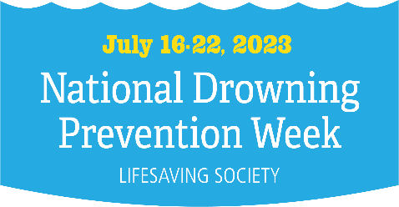

Name of Press Contact:
Date:
Phone:
Email:
MEDIA RELEASE
FOR IMMEDIATE RELEASE
Despite a downward trend, drowning is still the third leading cause of death in Canada. Drowning is preventable! Join Lifesaving Society Canada in bringing awareness to the drowning problem during National Drowning Prevent Week from 16th – 22nd July 2023.
[CITY], [PROVINCE/TERRITORY], [DATE] – The mission of Lifesaving Society Canada is to prevent drowning - even one drowning is one too many.
Over 450 people fatally drown annually in Canada, making it the second leading cause of unintentional death for children and the third leading cause of unintentional death for adults. In particular, Indigenous, northern and new Canadians have a disproportionately high mortality burden. In fact, the drowning burden is so great around the world that the United Nations General Assembly passed the UN Resolution on Drowning Prevention (A/75/L.76) and named July 25th of each year as World Drowning Prevention Day. During the week of July 16th – 22nd, 2023 Lifesaving Society of Canada will be educating and promoting safety awareness in, on and around the water.
Statistics show that almost 70% of drowning fatalities never intended to go into the water and were often within 15 metres of safety. Nearly every Canadian has known someone who has drowned or had a non-fatal drowning experience, whether personally or from his or her community. To help reduce drowning, all Canadians are encouraged to:
- Take the Lifesaving Society Swim to Survive Standard (teaches how to survive an unexpected fall into the water) and participate in a learn-to-swim program.
- Wear a properly fitted lifejacket when out on a boat.
- Refrain from drinking alcoholic beverages while participating in aquatic activities.
- Ensure that children are under the direct supervision of an adult when around barrier-free bodies of water.
The majority of drownings are preventable in a Water Smart community. Join [INSERT BRANCH/AFFILIATE] to participate in various events and activities to help make you a Water Smart community.
For more information, please contact [CONTACT INFO OF BRANCH / AFFILIATE / HOST]

