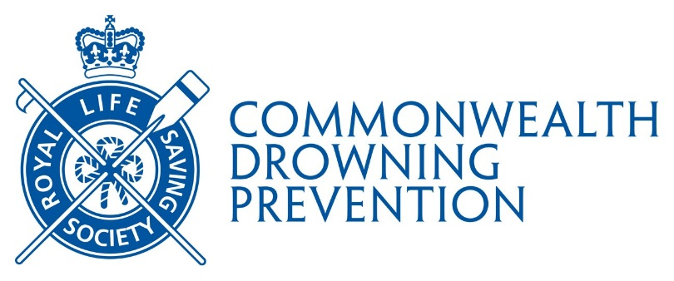

RLSS DIPLOMA

CALL FOR SUBMISSIONS

Apply for the RLSS Diploma if you or a team have contributed to the understanding of lifesaving and drowning prevention.
The Diploma is one of the Society’s oldest and most prestigious international awards.
The Diploma, which has taken many forms over the years, is also an opportunity for the RLSS to share research and drowning prevention achievements across all its member nations.
Today, the RLSS Diploma is awarded to individuals and teams, who have added to our knowledge in ways that can save lives and prevent drowning. They may have produced a single piece of work with high impact, or made multiple contributions over time.
Theory, research, and practice based work all count. There are many different types of work that could qualify, including:
- effective broad-based communication or campaigns (for example, a magazine article that targeted changing risky behaviour)
- research reports (such as research studies, and literature reviews)
- analysis and presentation of data (perhaps applied studies of drowning statistics)
- reviews of community engagement activity (including drowning prevention campaigns)
- demonstrations of improved practices (possibly comparisons of rescue practices, or comprehensive reviews of equipment)
There’s no limit to the range of topics considered except that it has relevance to Royal Life Saving. Some obvious examples include:
- lifesaving and lifeguarding equipment, training and practice
- the epidemiology of drowning
- drowning prevention programmes and practice
- flooding and natural disaster resilience
- lifesaving sport
- aquatic operations and risk management
- changing the behaviour of individuals and society
- studies of partnerships with other agencies
- water safety policy
- ice safety

If you want help with an application (or a project) contact your National Branch for guidance. They may have suggestions of topics or areas for study or research that would be particularly helpful. As well they may have access to people and resources to support this work, and may be able to provide useful background information or relevant research.
There are no restrictions on who can apply, applicants may be in the final stages of their secondary education, university students, graduate students or recent graduates, professionals working in a related field (such as lifeguards, pool managers, fire-fighters, or those working in recreation, health care, or policy), as well as junior and senior academics. One of the applicants needs to be from a member country of the Royal Life Saving Society (RLSS) (See http://www.rlsscommonwealth.org/rlss-members/)
The Diploma recognises contributions to our Life Saving knowledge, and while these could take many forms, it is important that this can be understood and applied by others in similar situations. There needs to be sufficient evidence to support any conclusions, experimental work needs to meet appropriate standards, and deductions need to be realistic. If in doubt, contact the RLSS Headquarters for guidance at commonwealth@rlss.org.uk).

How to apply:

- To apply you need to submit a detailed report or evidence of your work. Exactly what form this will take, will depend on the nature of your work. Most entries will consist of a written report or publication(s), however, if you would like advice, contact the RLSS Headquarters (commonwealth@rlss.org.uk) and we will be pleased to discuss this with you.

- Entries must be accompanied by a completed application form. This is a brief summary of the work to ensure that the right people are involved in its assessment. You may complete this in bullet points if you wish.

- The application form includes a declaration that the work submitted for consideration was carried out by the applicant, and that, if appropriate, other people’s contributions have been acknowledged and/or appropriately referenced. RLSS reserves the right to undertake verification of originality including via online website.

- Where a project or publication was developed/completed by a team, the award will not be given to an individual.

- Applications are reviewed by the RLSS Commonwealth Diploma Selection Committee each quarter and submission deadlines are: March 31st, June 30th, September 30th and December 31st. Entries received after the deadline will be considered after the following deadline.

- Completed applications should be submitted via email to commonwealth@rlss.org.uk. If this is not practical (e.g., perhaps because application includes physical materials), please discuss specific entry with RLSS Headquarters before sending anything.

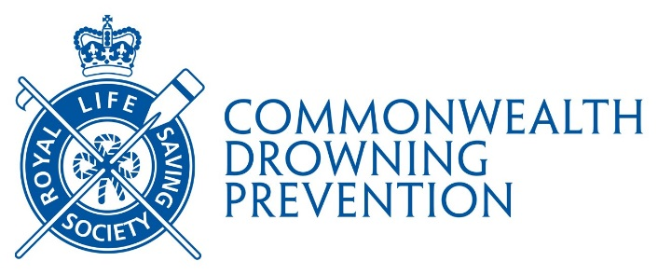

RLSS COMMONWEALTH DIPLOMA APPLICATION FORM
About you | Name of nominee(s):
About you | Correspondence address:
About you | Email address(es):

About your application | Topic(s): Indicate all that apply  Aquatic operations  Aquatic risk management  Drowning and near drowning  Drowning prevention programmes and practices  Ice safety  Lifeguarding | Lifesaving  Lifesaving sport  Safe waters  Politics and partnerships  Social or behavioural change  Other: Details please
About your application | Brief description of contribution: (2-3 sentences)  Where was this work conducted?  Over what time period was this work conducted?  What impact might/did this contribution have?

Attached/included evidence: (Please submit documents or publication in .doc, docx, .txt or pdf format (not image)
Yes
To follow. Details please
Declaration

I confirm that that all of my/our work, submitted for consideration, was carried out by myself or our team, and that any and all contributions by others have been acknowledged and/or appropriately referenced.

Date:
Signature on behalf of the applicant(s)

Assignments, e.g. graduate work, prepared for another institution should be submitted after it has been marked, needed corrections completed and attestation of same should be noted with application.

